Assignment 1

- F = (A.B) + (C’)

Verilog Code:
module ass1(
input A, B, C,
output F
);

assign F = (A & B) | (~C);

endmodule

Waveform:
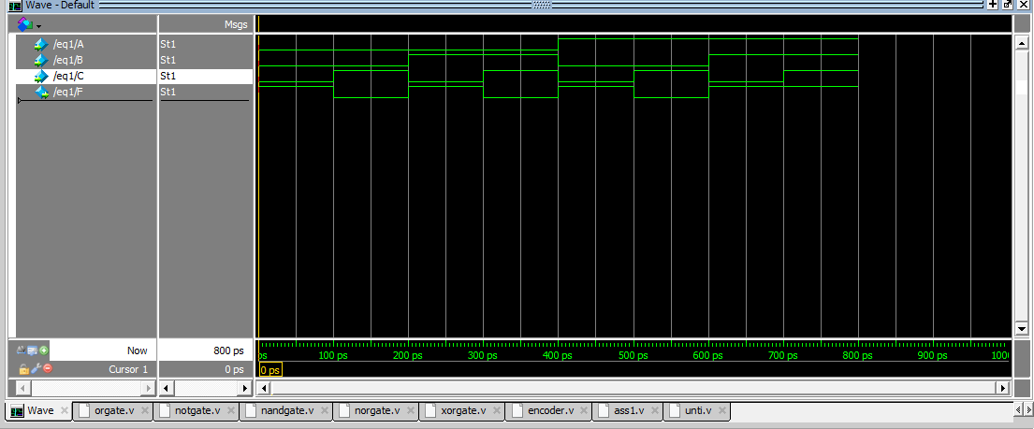

- F = (A.B) + (A’.C)

Verilog Code:

module ass2(
input A,B,C,
output F
);
assign F = (A&B) | ((~A)&(C));
endmodule

Waveform:
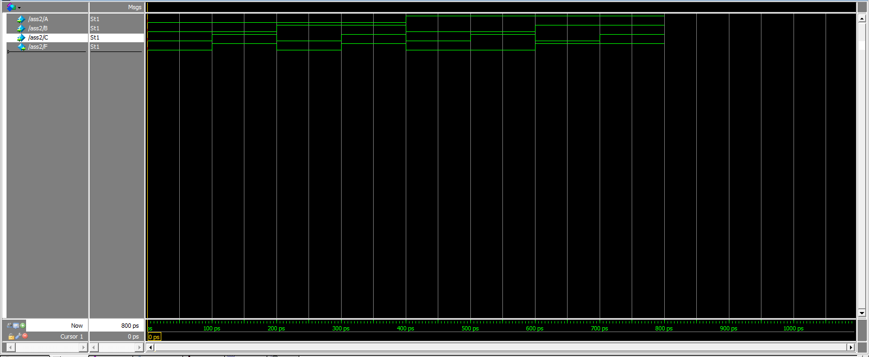

- F = (A+B) + B’.C’

Verilog Code:
module ass3(
input A,B,C,
output F
);
assign F = (A|B) | ((~B)&(~C));
endmodule

Waveform:
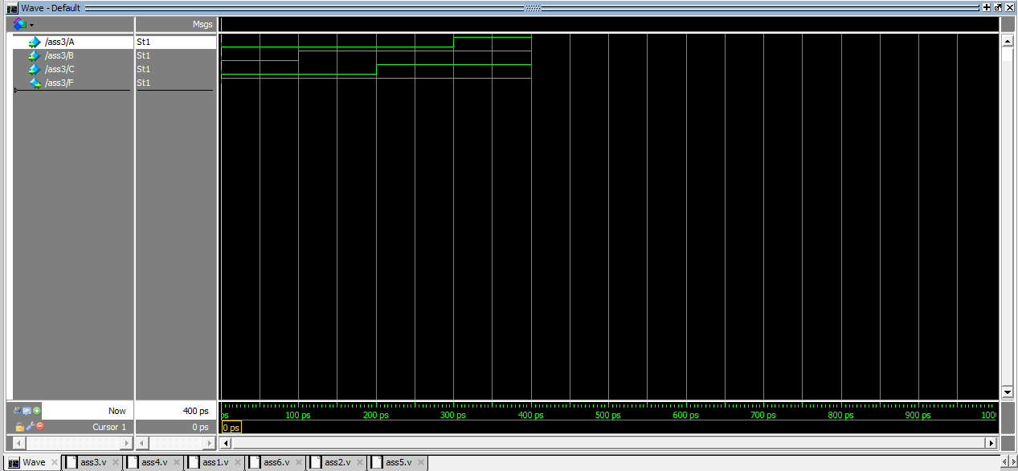

- F = (A.B.C) + (A’. D) + (B. C’D)

Verilog Code:
module ass4(
input A,B,C,D,
output F
);
assign F = (A&B&C) | ((~A)&(D)) | (B&(~C)&D);
endmodule

Waveform: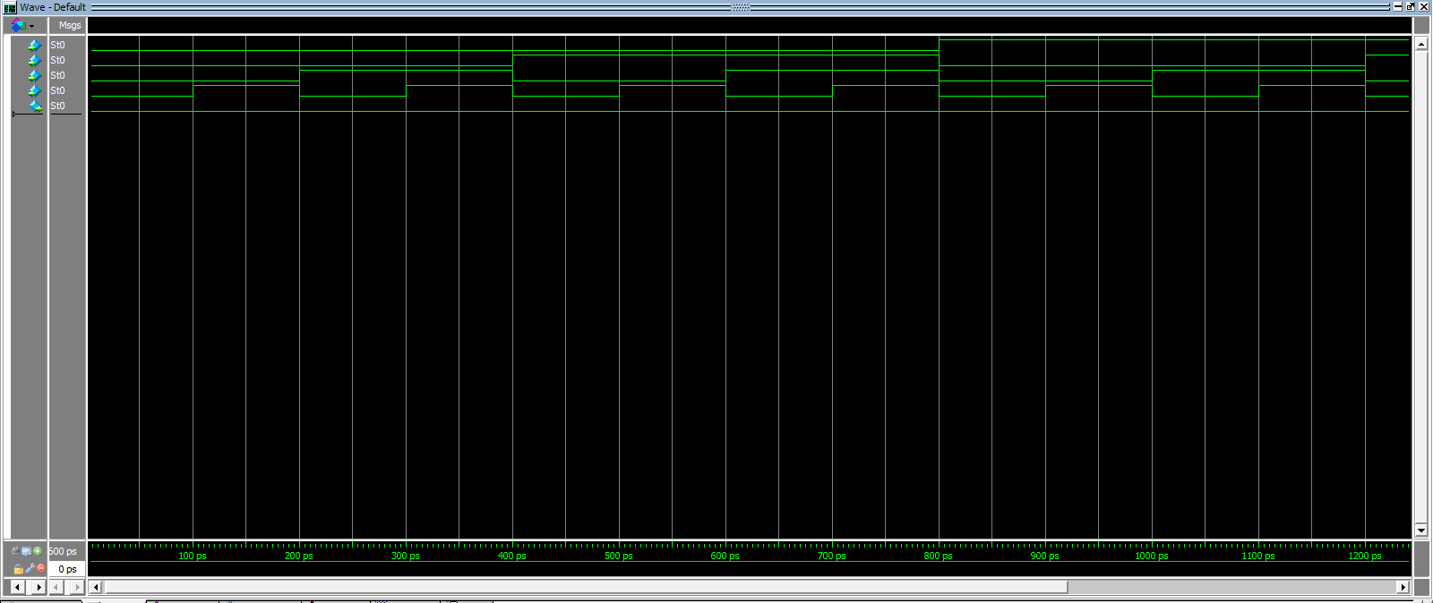

- F = (A.B)+(C’.D)+(B ^ C)

Verilog Code:
module ass5(
input A, B, C, D,

output F

);

assign F = (A & B) | ((~C) & D) | (B ^ C);

endmodule

Waveform:
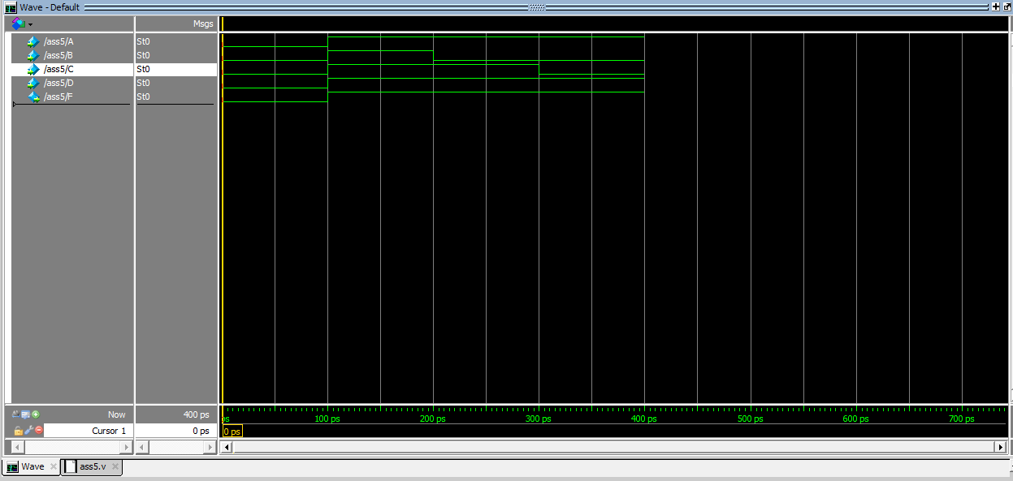

- Y = (A.B) +(C’+B’) + (E’. F)

Verilog Code:
module ass6(
input A, B, C, E, F,
output Y
);
assign Y = (A & B) | ((~C) & (~B)) | ((~E) & F);
endmodule

Waveform:
